PATTERN MATCHING WITH REGULAR EXPRESSIONS AND PARSING STRUCTURED DATA – LAB 05

5C 5080 – SOFTWARE CONSTRUCTION

WIAJYAWARDHANA W.A.H.A.

2019/E/166

SEMESTER 05

11 OCTOBER 2022

QUESTION 02

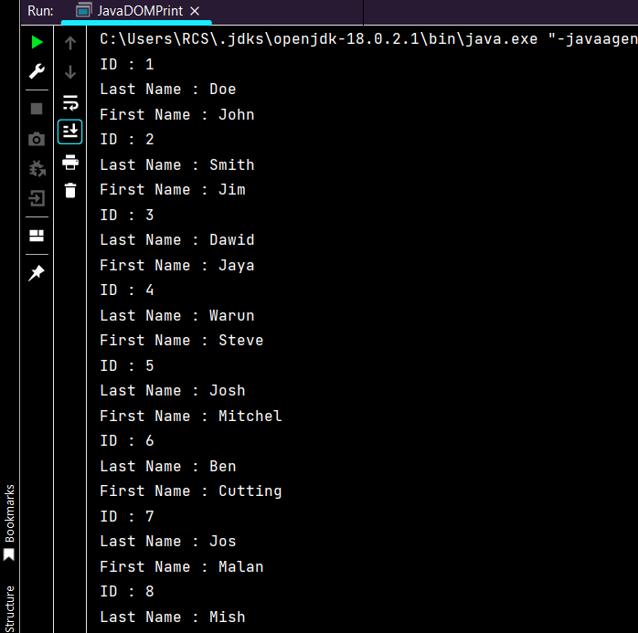

QUESTION 03

